Information Security Policies Report for Wales Interiors

Table of Contents

Introduction 3

Purpose 4

Policies Implemented 5

1. Clear Desk and Clear Screen Policy for Wales Interiors 5

2. Data Classification for Wales Interior 6

3. Identity Management and Access Control Policy for Wales Interior 8

4. Incident Management Policy for Wales Interiors 10

5. Password Construction Standard for Wales Interiors 12

6. Physical Security Management Policy for Wales Interiors 13

7. Remote Working Security Policy for Wales Interiors 15

8. Secure Configuration Policy for Wales Interiors 17

9. Technology Equipment Disposal Standard for Wales Interiors 18

10. Third-Party Management Policy for Wales Interiors 20

Upload Policies to Wizer 22

Recommendation 25

Conclusion 26

# Introduction

Wales Interiors, a luxury design and furniture manufacturer, is undergoing digital transformation to support its business growth and expand market share. As part of this initiative, the company has migrated key assets such as design files, client contracts, and financial records to cloud storage and now leverages Microsoft 365, Google Drive, and a custom-built Enterprise Resource Planning (ERP) system to streamline daily operations.

However, this digital evolution has introduced new cybersecurity risks, prompting the leadership team to prioritise internal risk assessments, safeguard sensitive data, and ensure compliance with legal and industry standards.

Although an internal GRC review identified a gap in seven critical policies, Wales Interiors has proactively decided to implement three additional security policies:

1. Password Construction Standard
2. Technology Equipment Disposal Standard
3. Third Party Management Policy

These policies were strategically selected to align with the organisation’s business objectives, meet industry expectations, address current cybersecurity threats, and support the evolving workplace culture.

# Purpose

The purpose of this report is to assess Wales Interiors’ current information security posture, identify gaps through risk and compliance analysis, and recommend practical policies aligned with ISO/IEC 27002:2022 standards. The report aims to support the organisation’s digital transformation goals by enhancing data protection, improving regulatory compliance, and building stakeholder trust through the implementation of robust security controls and governance practices.

# Policies Implemented

Wales Interiors has decided to create and implement the following policies listed below to meet regulatory requirements and gain a competitive advantage to strengthen its security posture. This would reduce financial loss, reputation loss, operational disruption, and legal consequences.

## Clear Desk and Clear Screen Policy for Wales Interiors

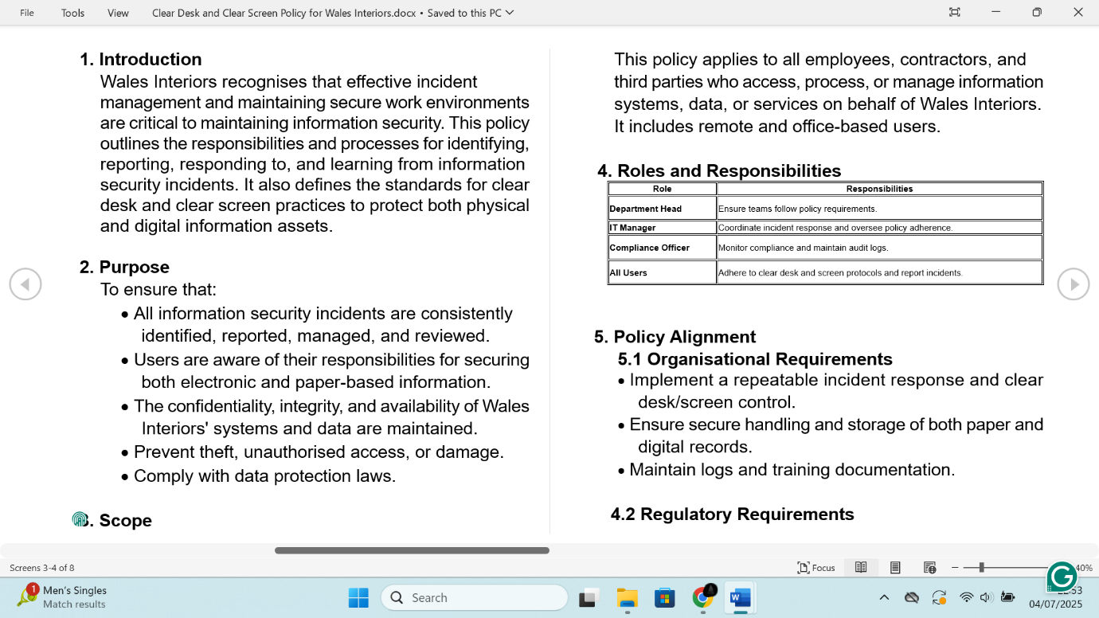

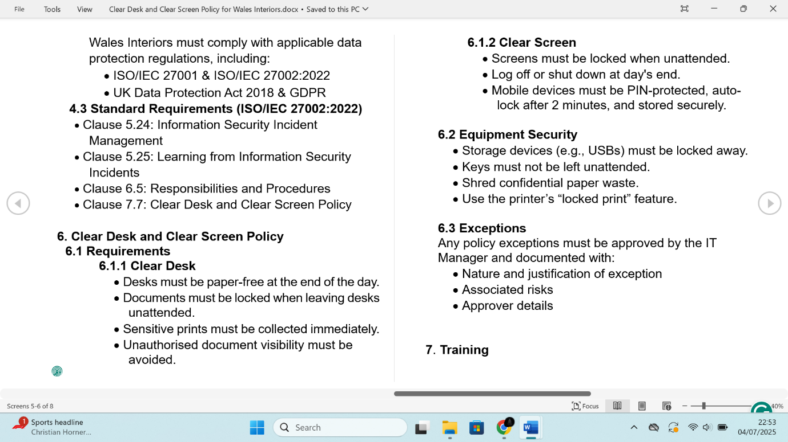

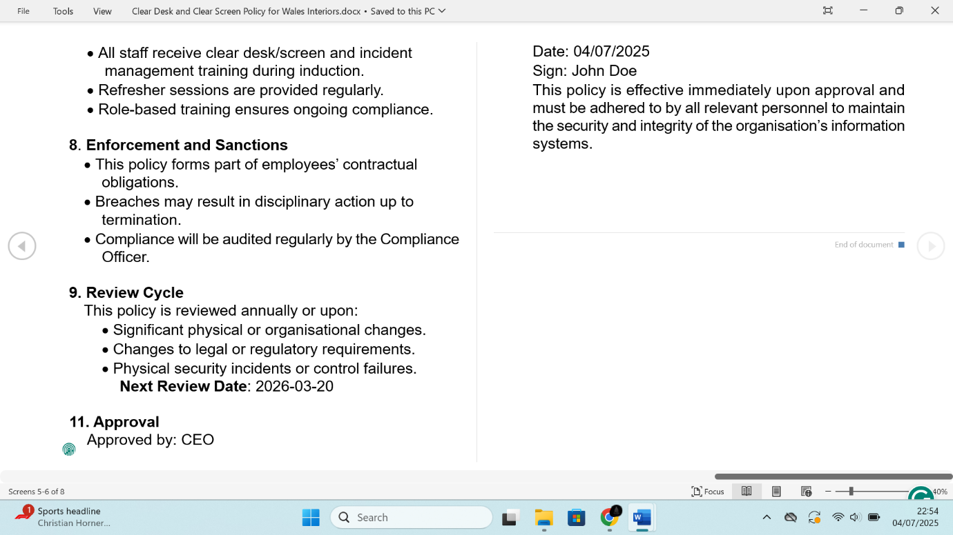

## Data Classification for Wales Interior

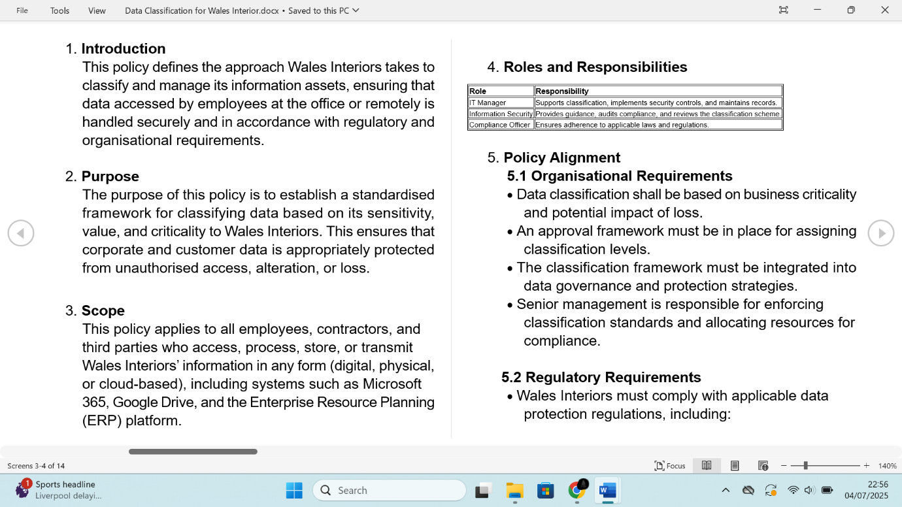

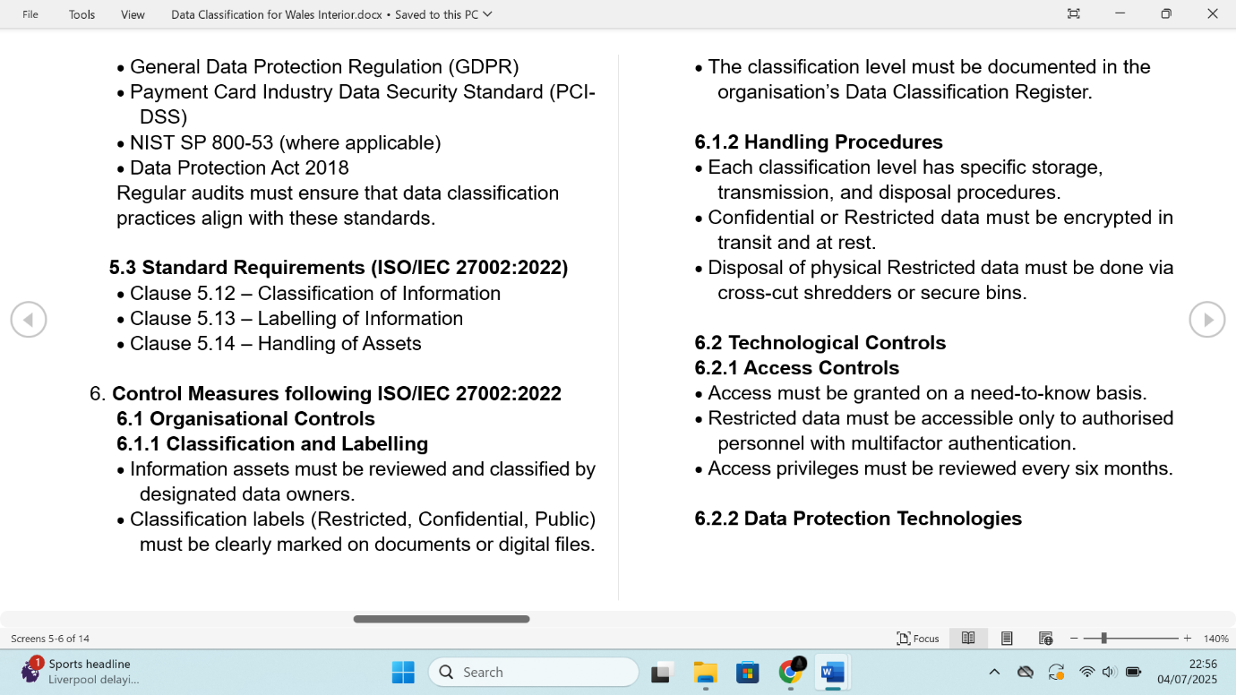

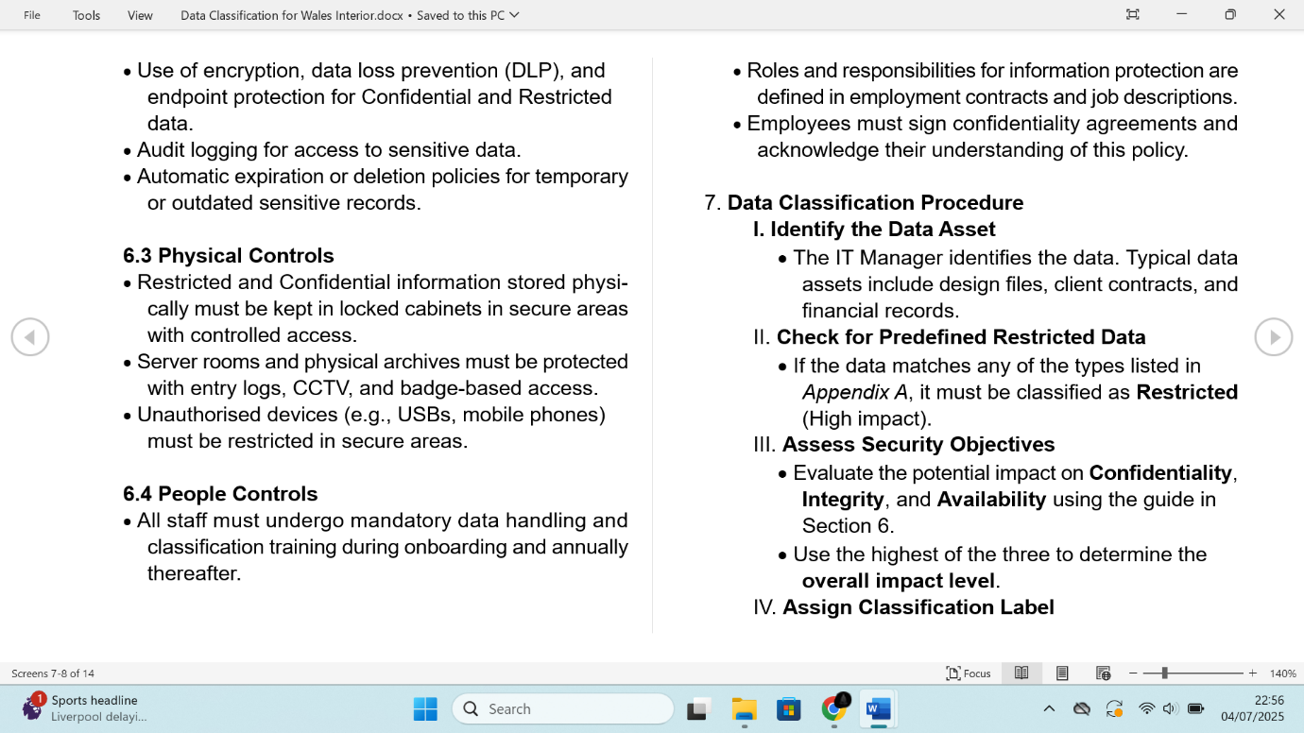

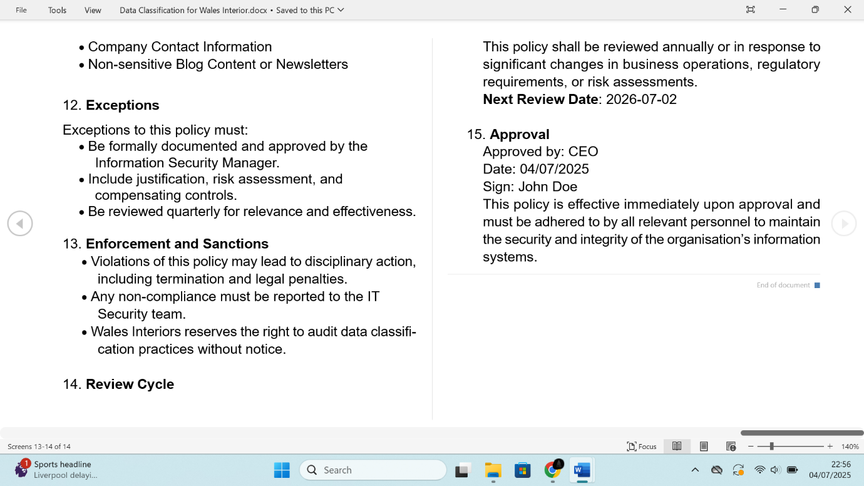

## Identity Management and Access Control Policy for Wales Interior

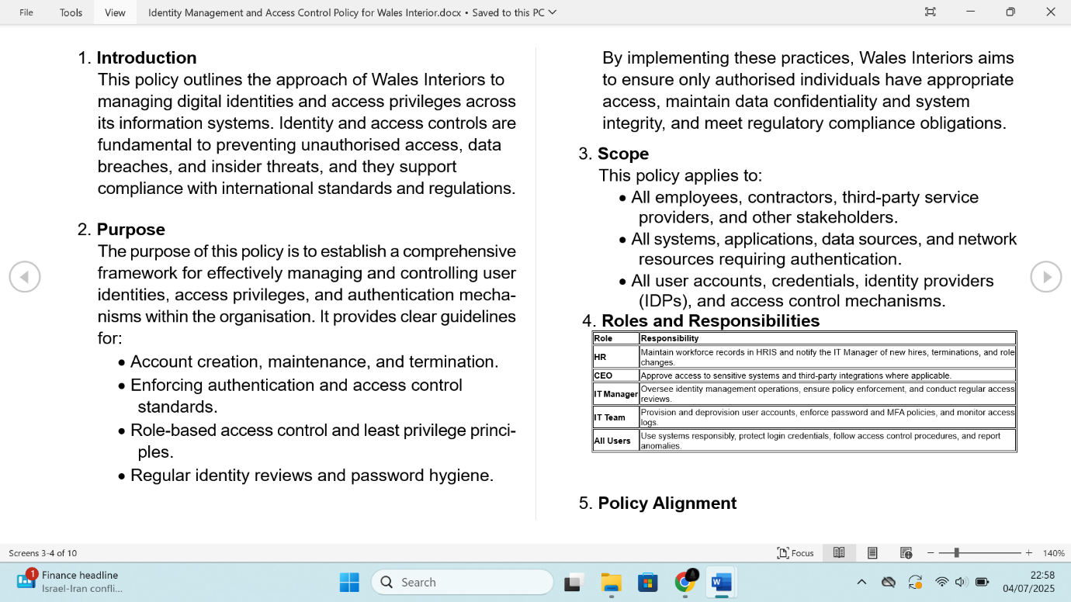

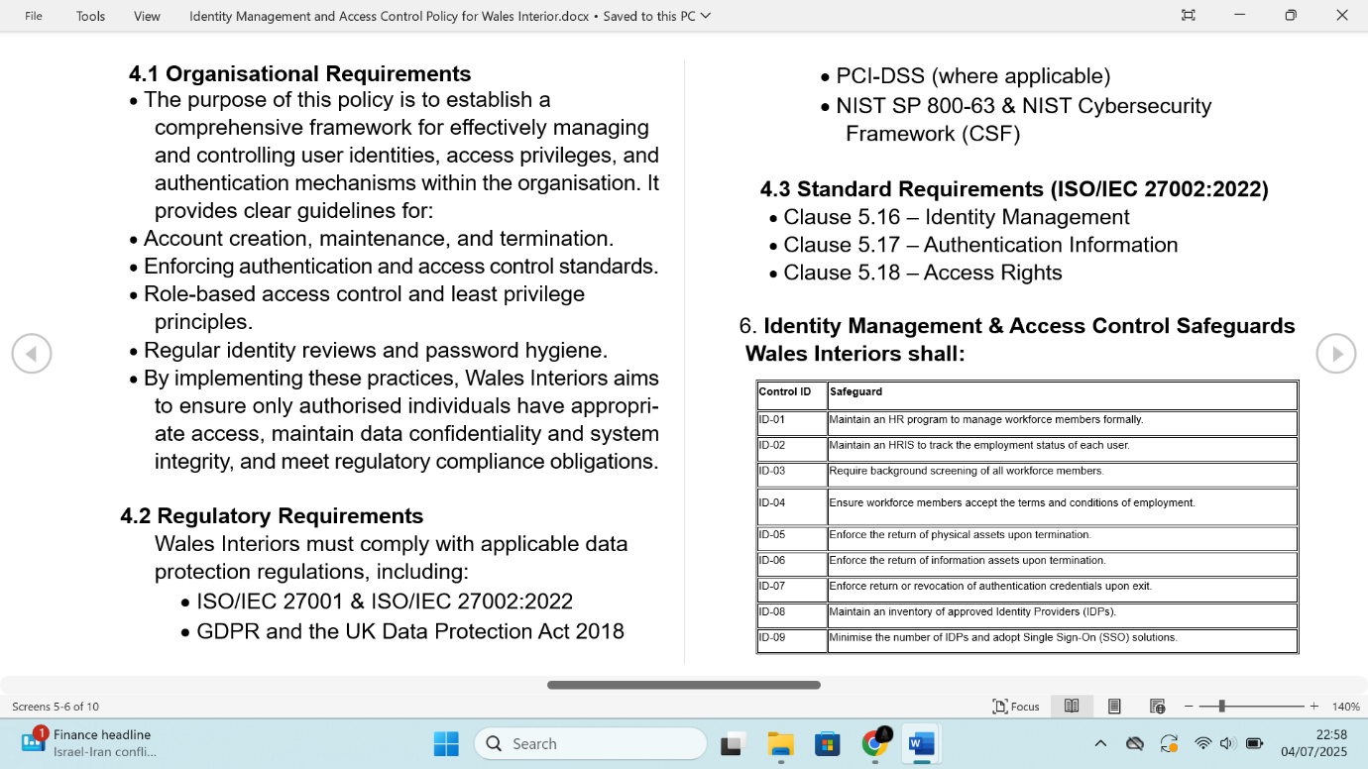

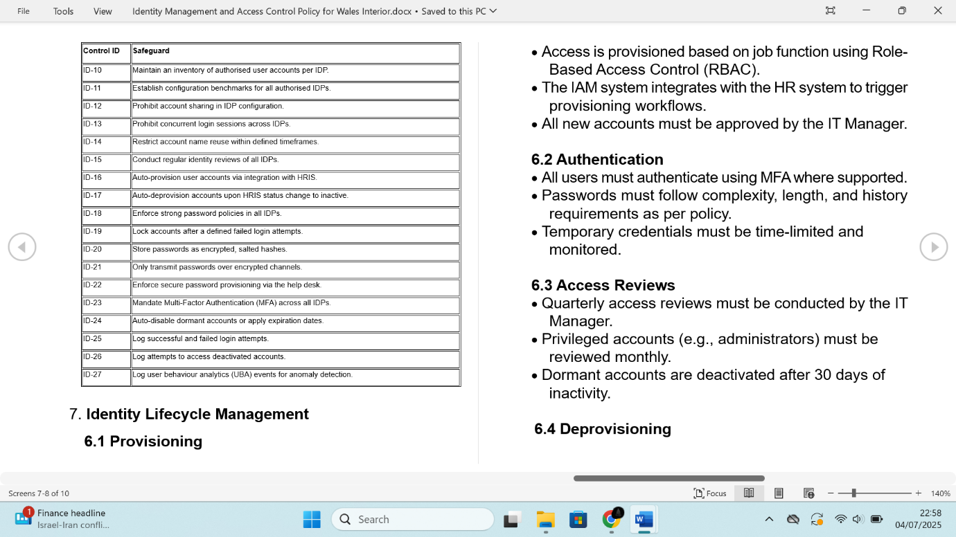

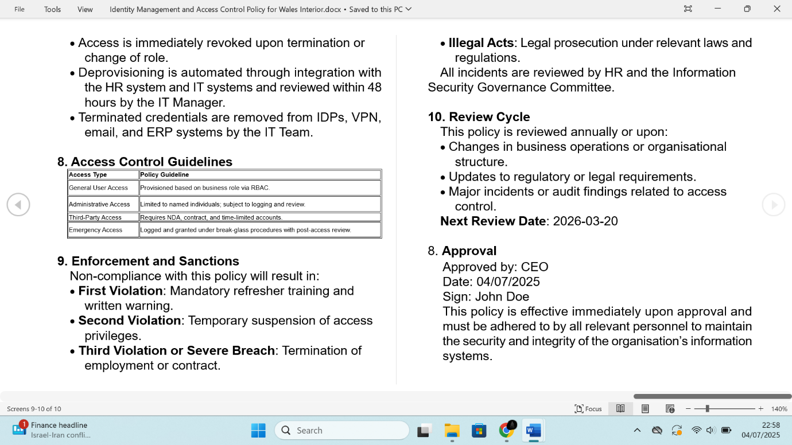

## Incident Management Policy for Wales Interiors

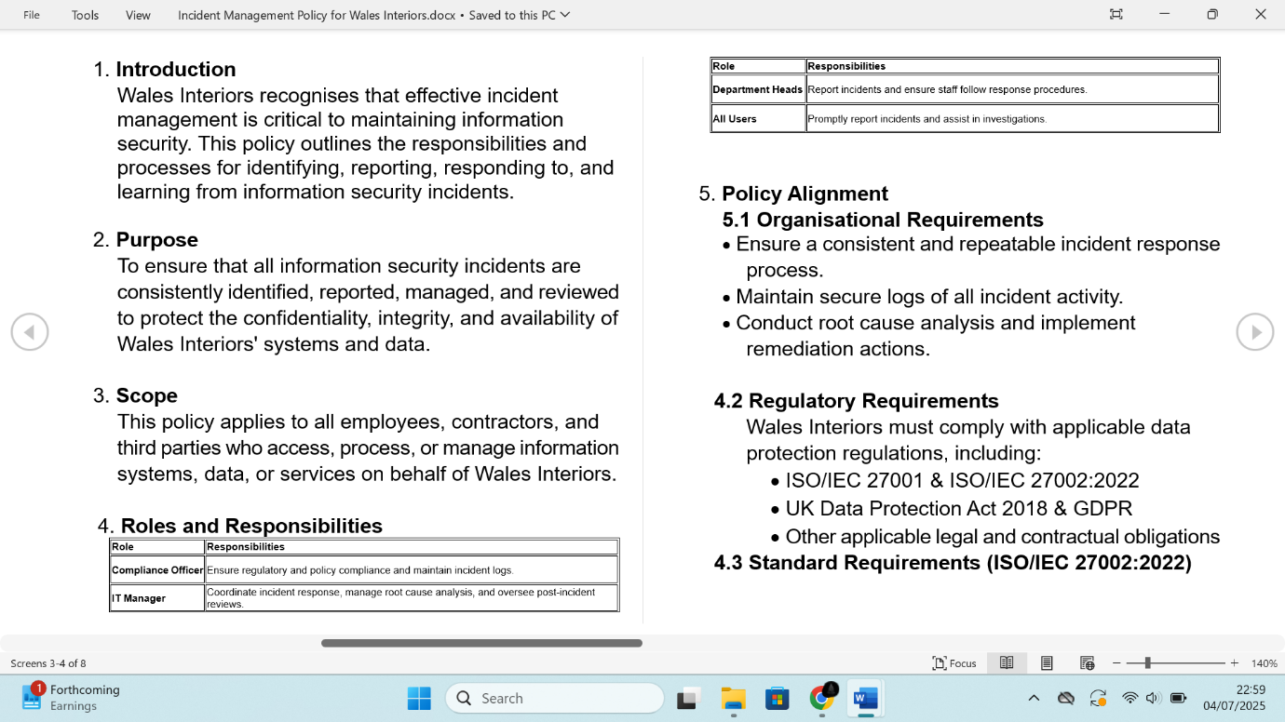

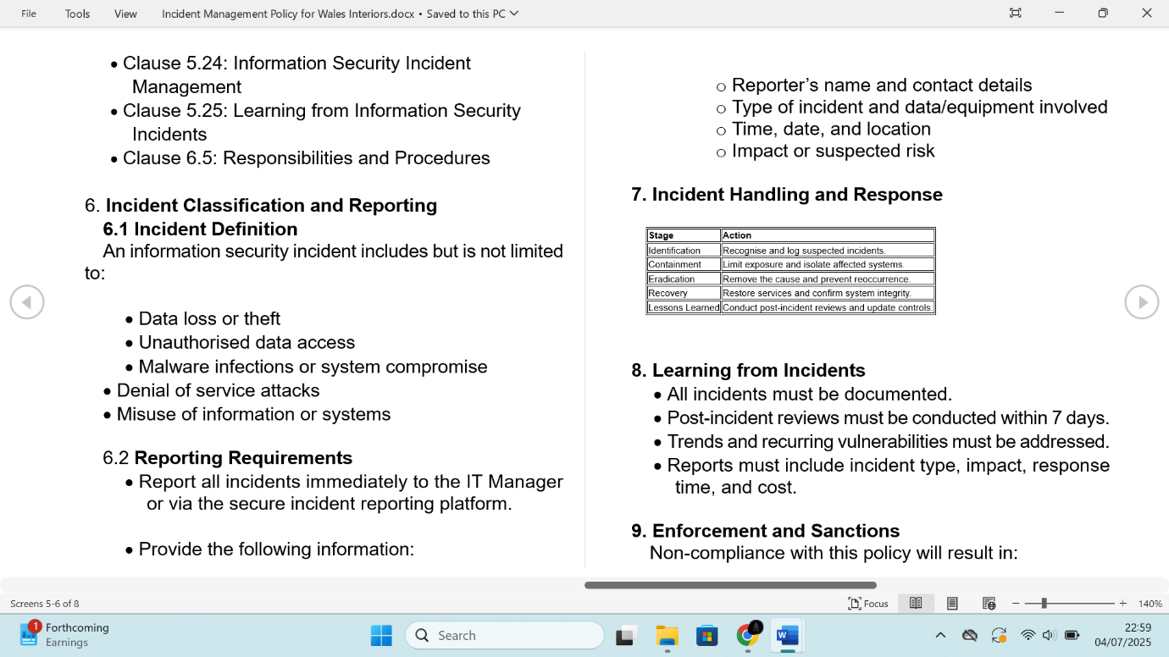

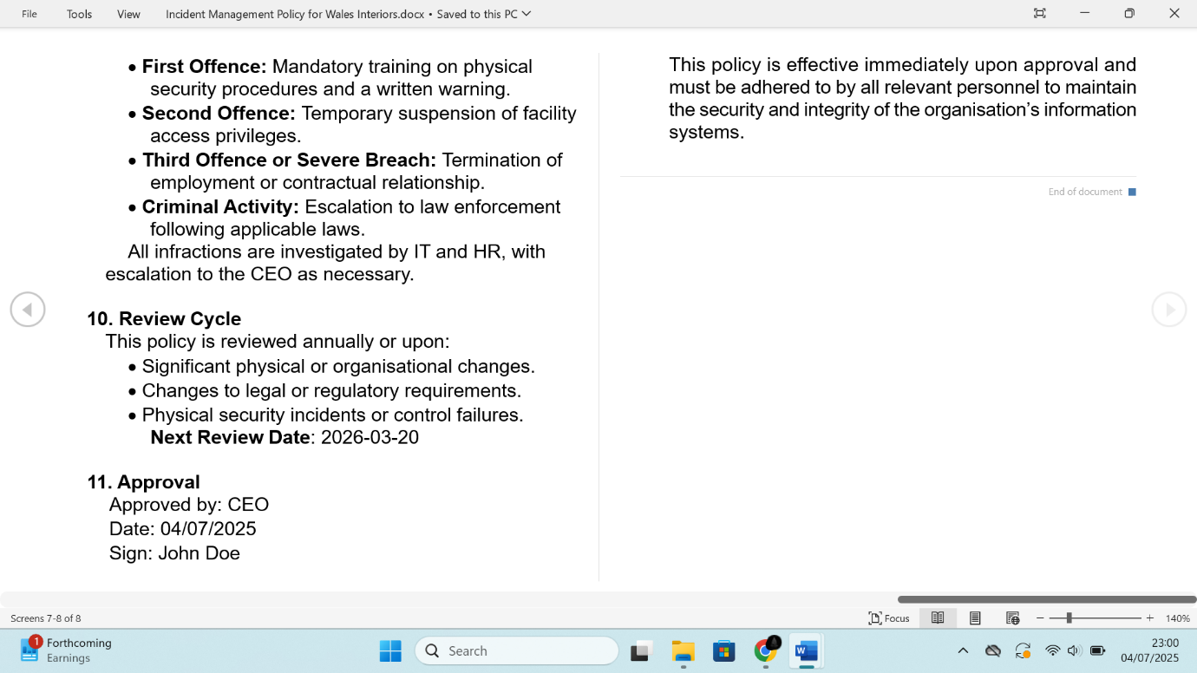

## Password Construction Standard for Wales Interiors

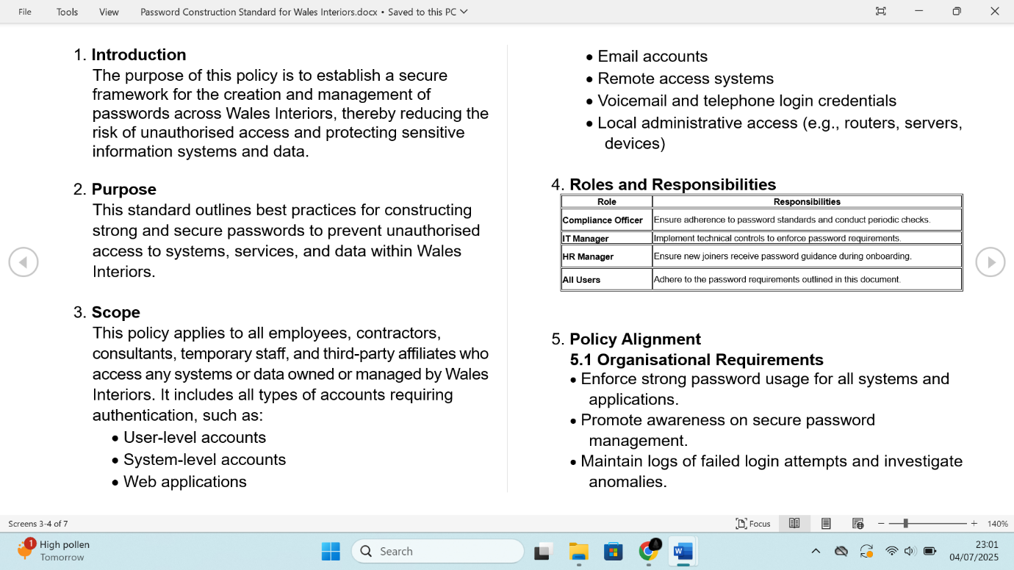

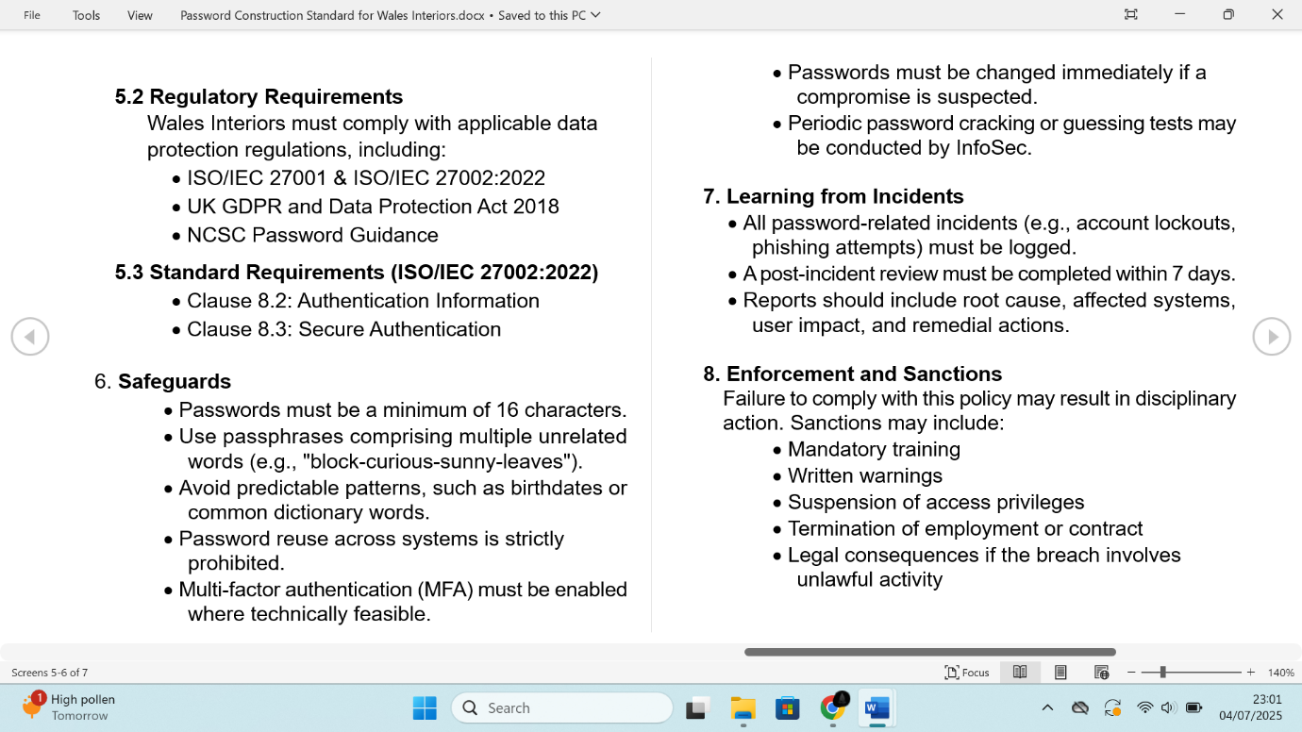

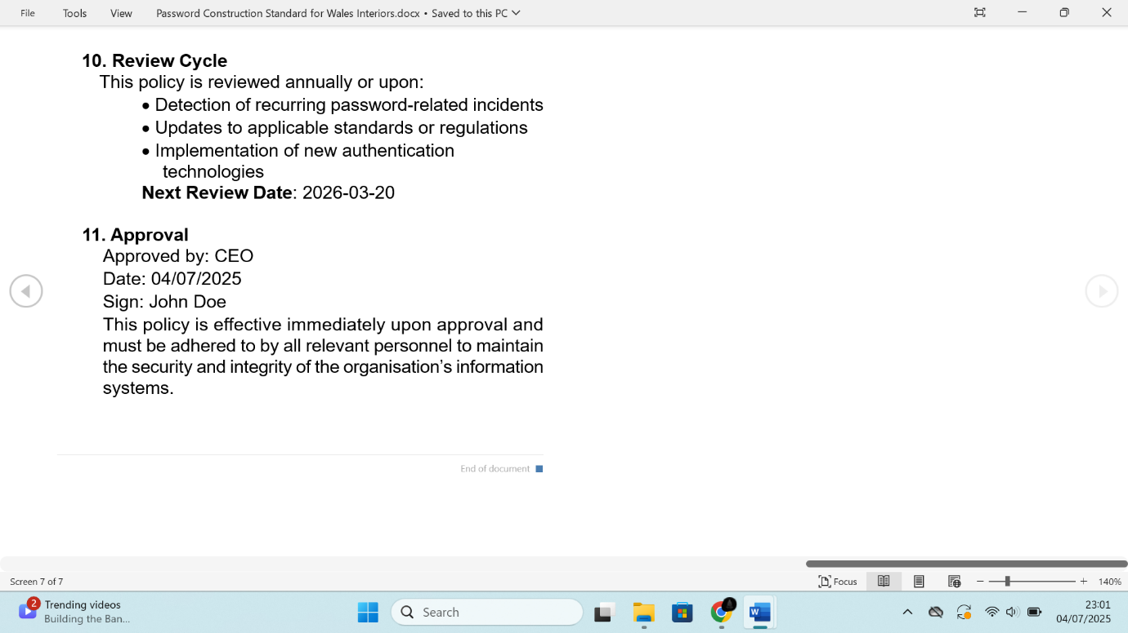

## Physical Security Management Policy for Wales Interiors

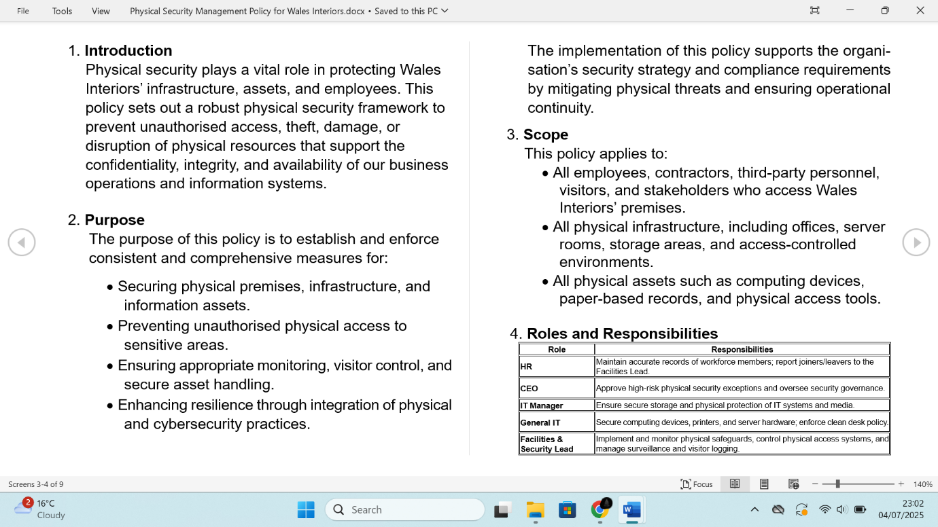

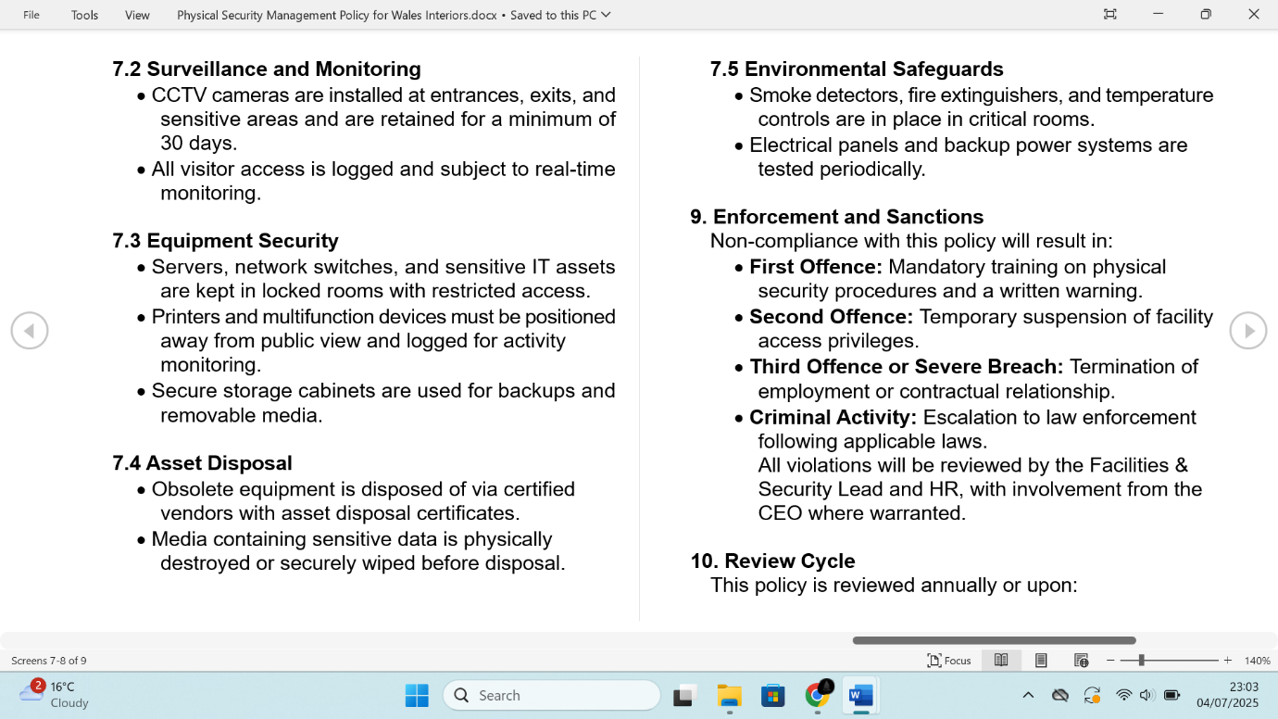



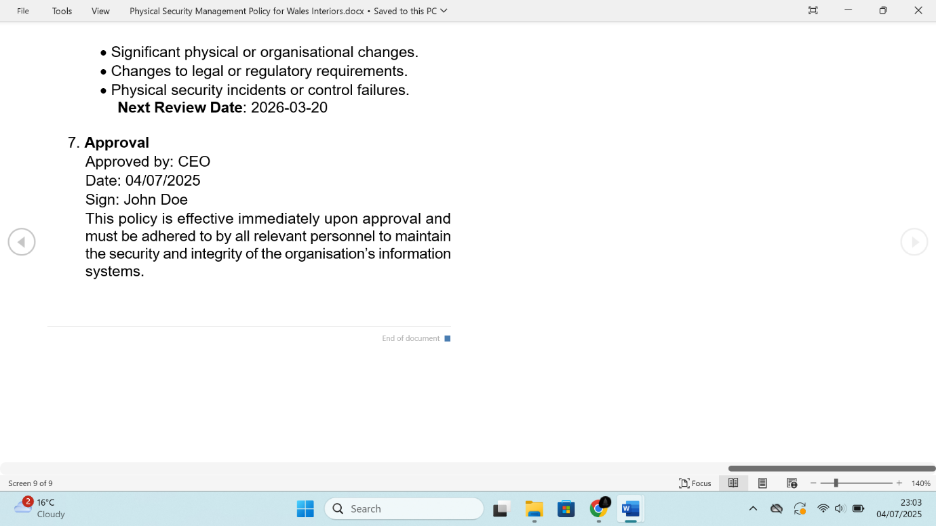

## Remote Working Security Policy for Wales Interiors

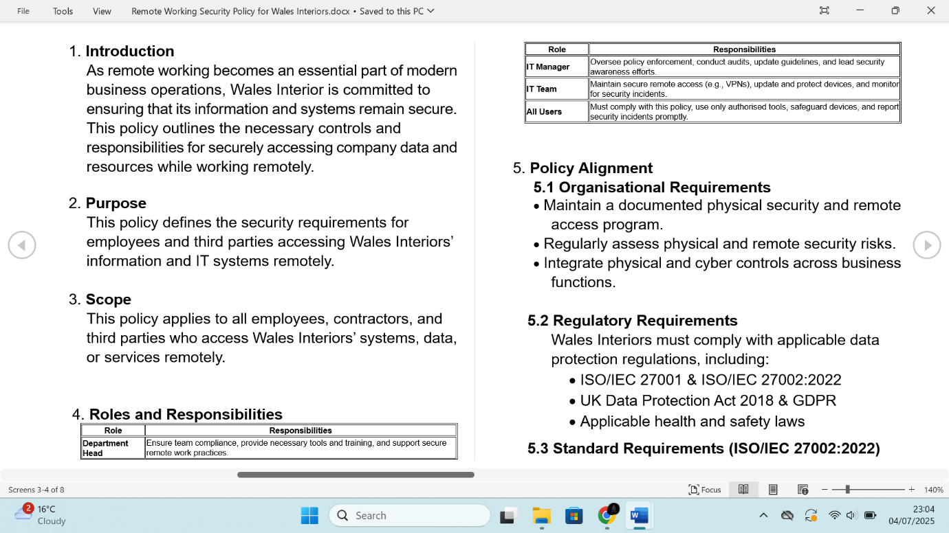

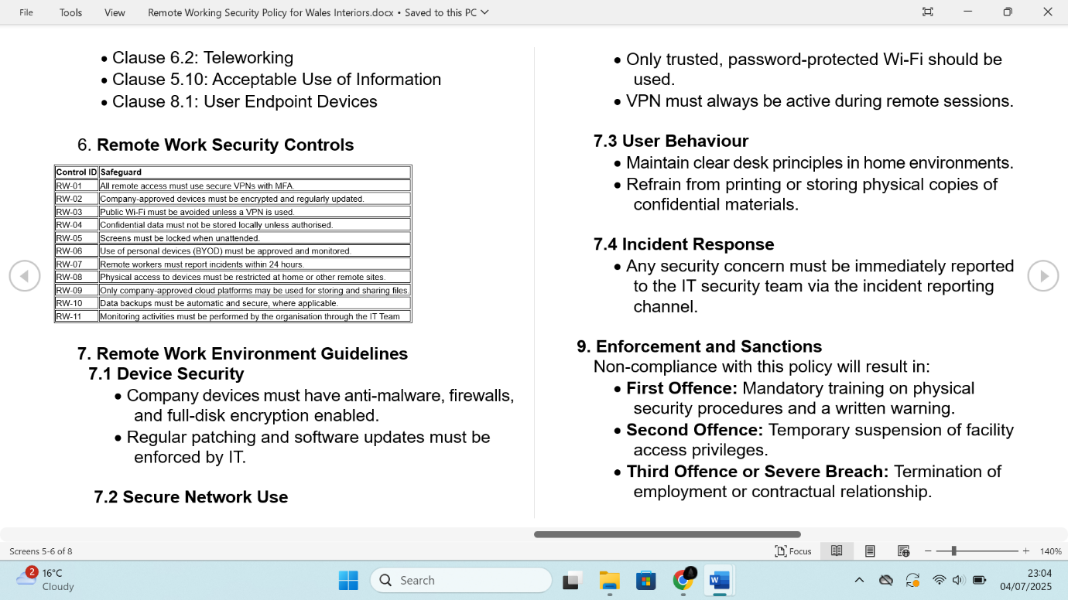

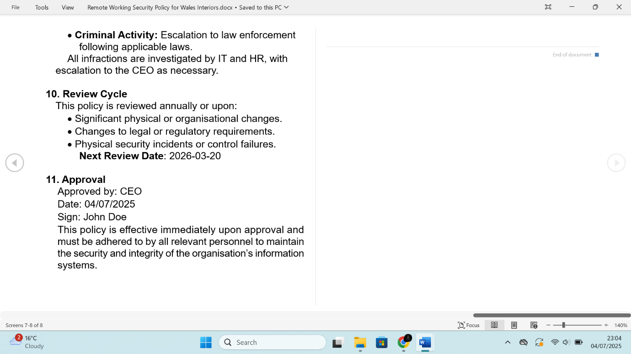

## Secure Configuration Policy for Wales Interiors

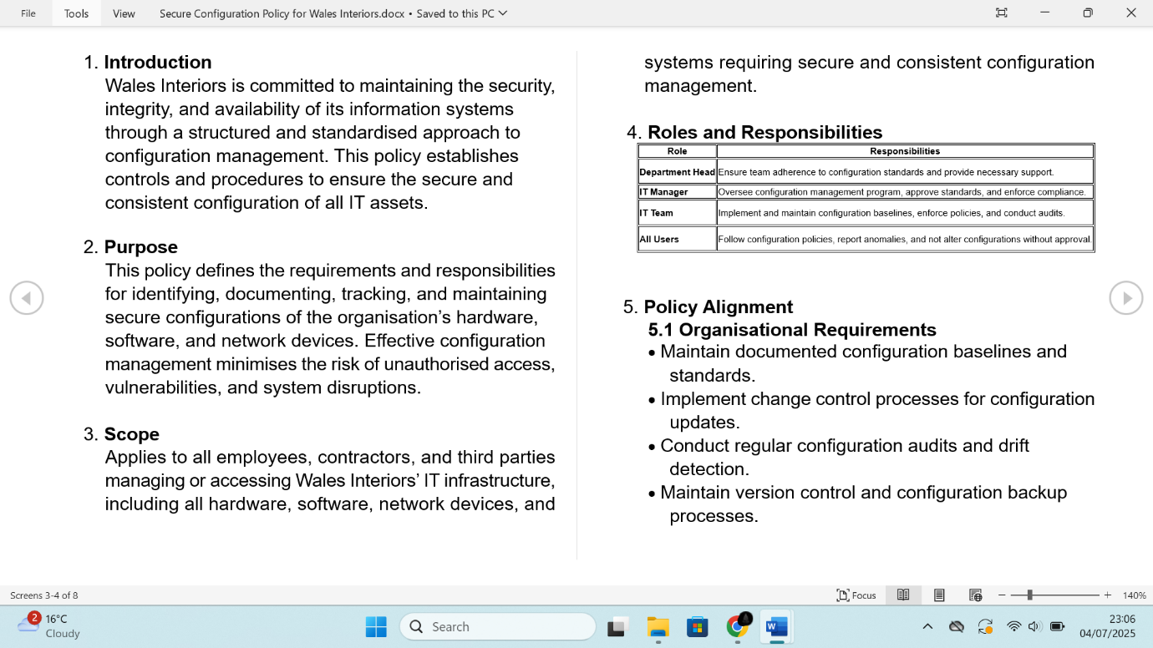

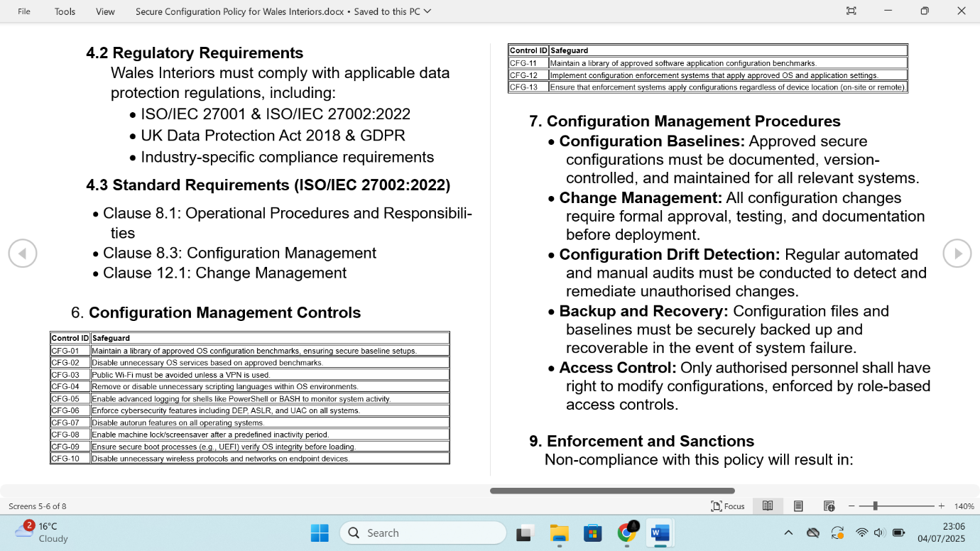

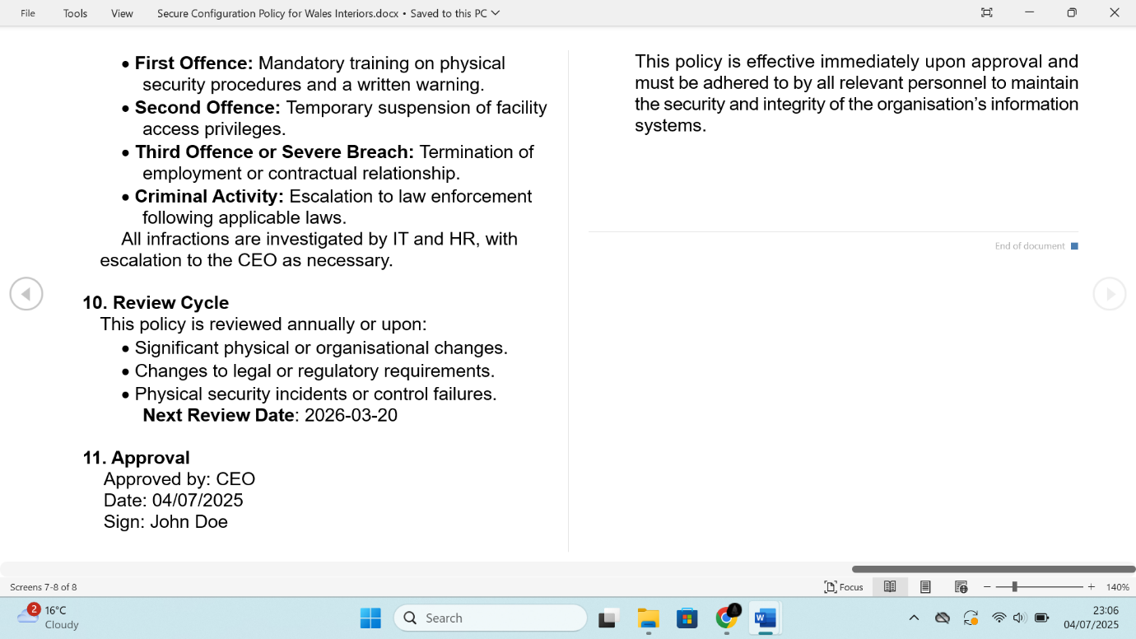

## Technology Equipment Disposal Standard for Wales Interiors

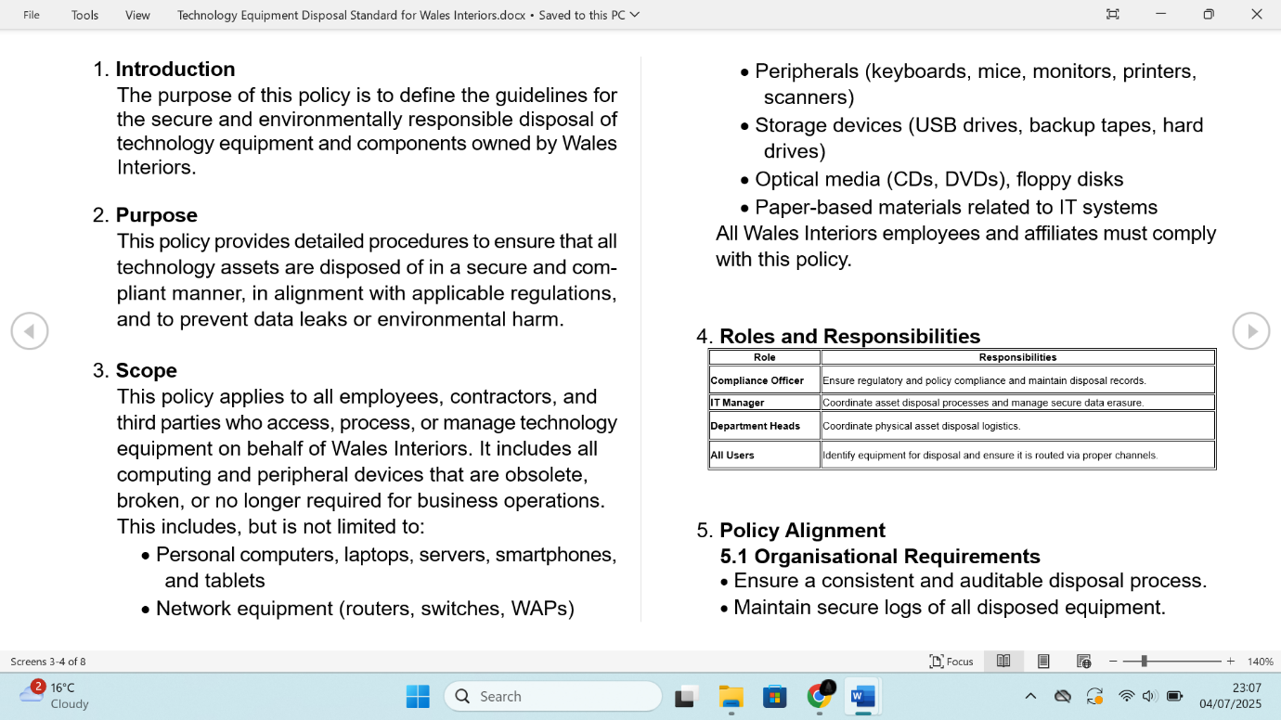

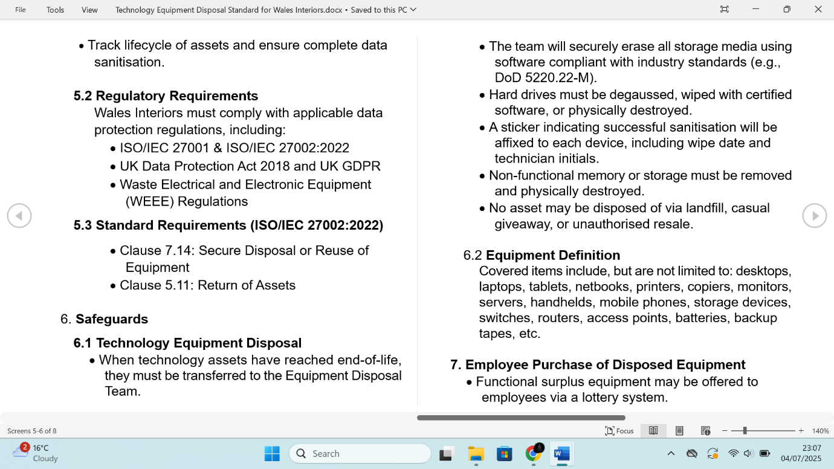

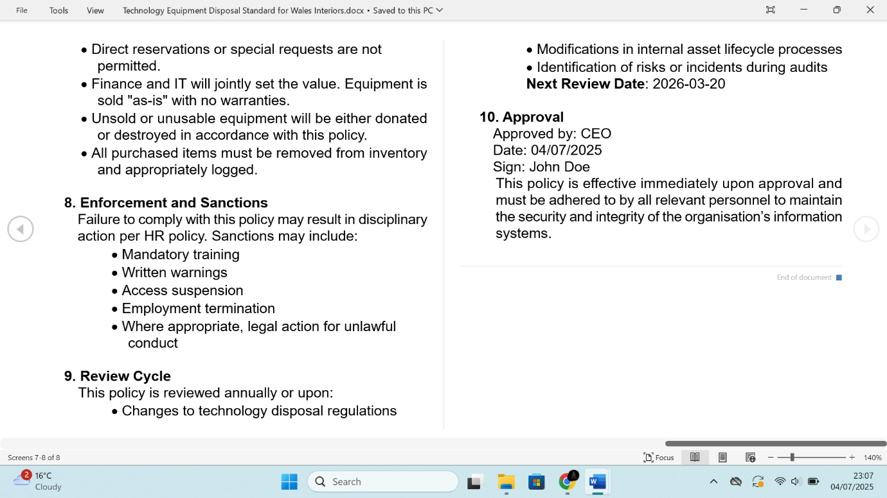

## Third-Party Management Policy for Wales Interiors

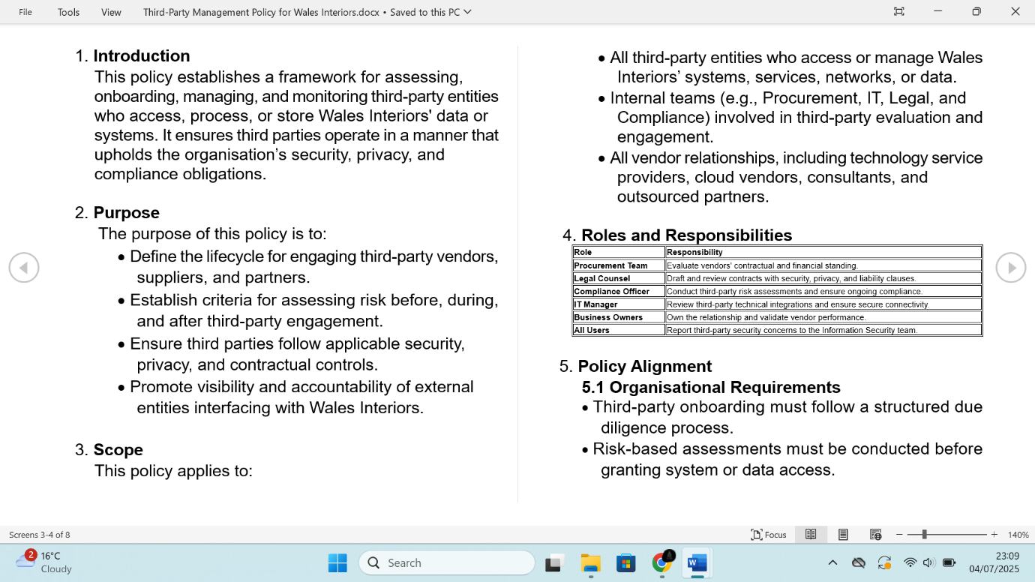

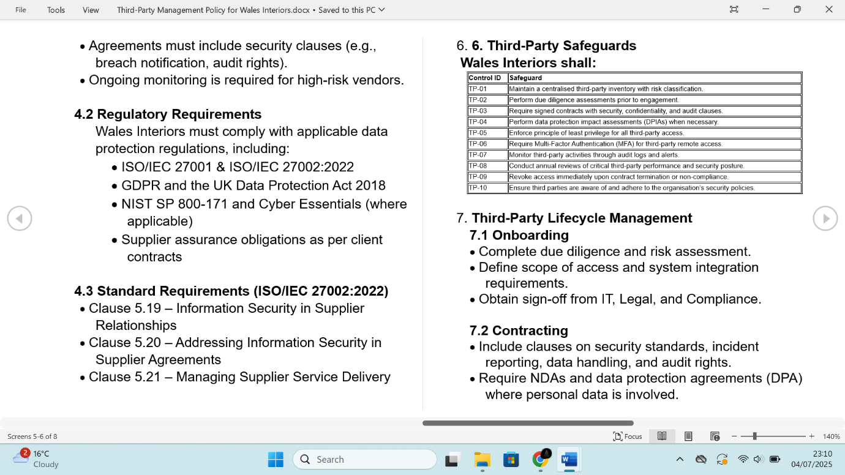

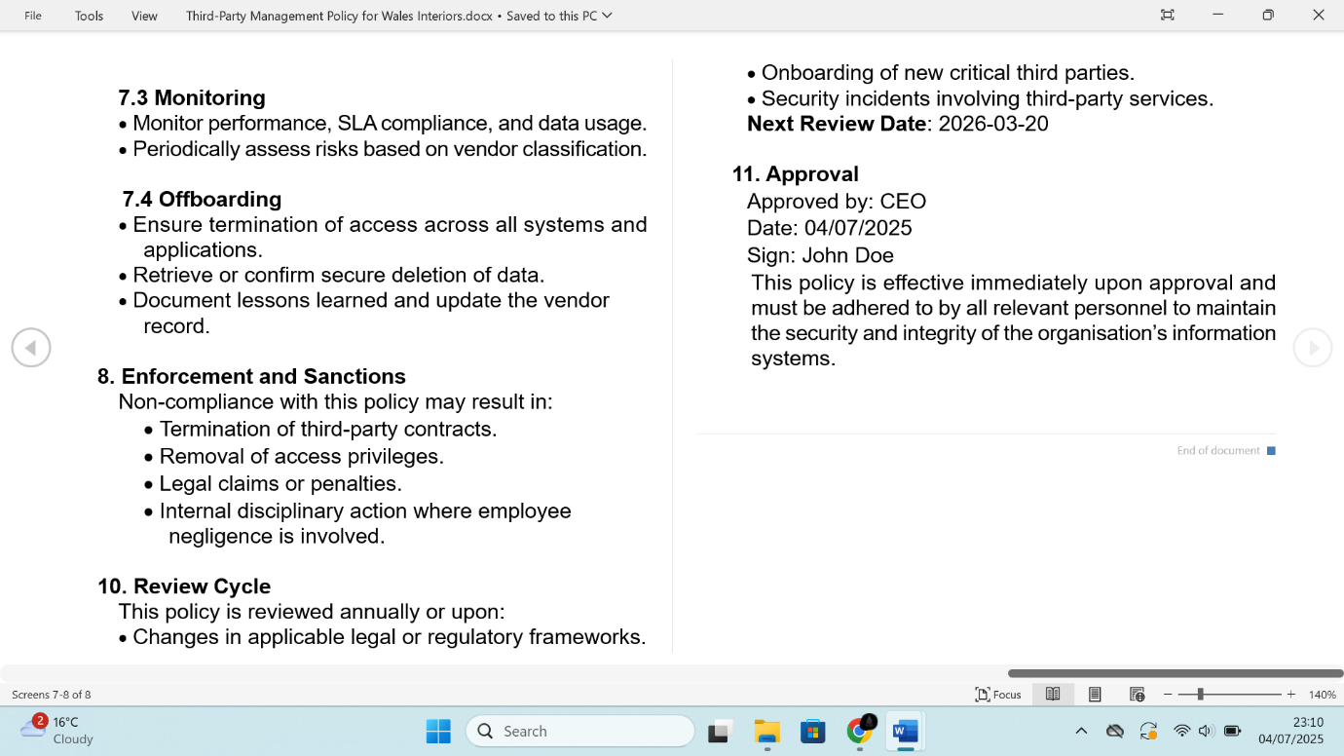

# Upload Policies to Wizer

All policies were thoroughly reviewed, formally approved, and uploaded to Wizer to ensure organisation-wide accessibility. A company-wide communication was issued to inform all staff of the updated policies and procedures. Employees reviewed and acknowledged their understanding and compliance, reinforcing Wales Interiors’ commitment to maintaining a strong security posture in line with industry best practices, ISO/IEC 27002:2022 standard, and supporting the organisation’s drive for competitive advantage.

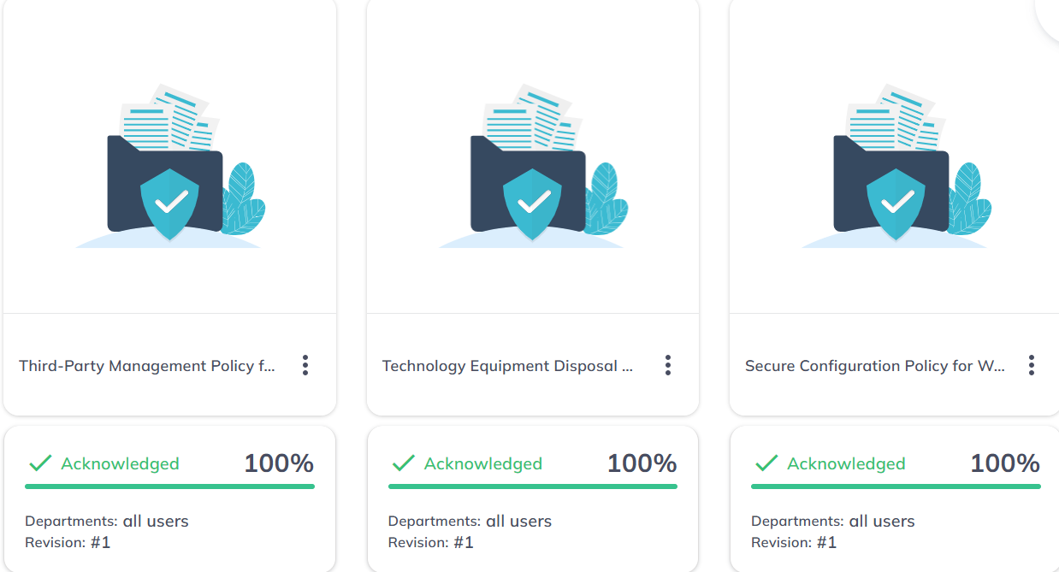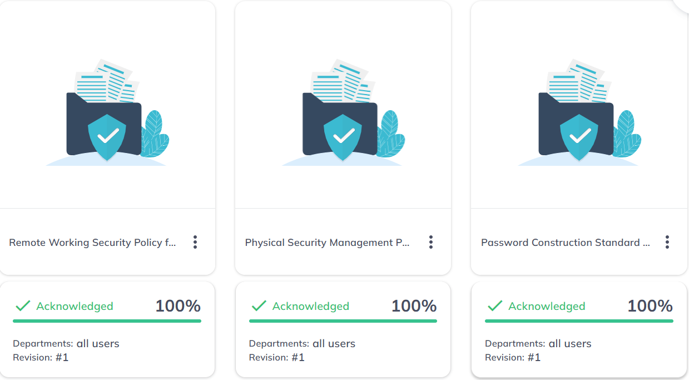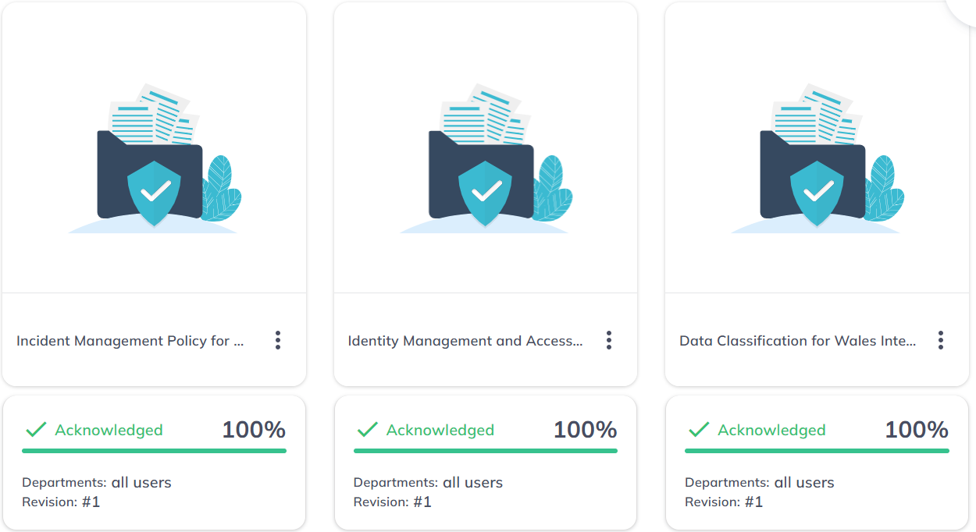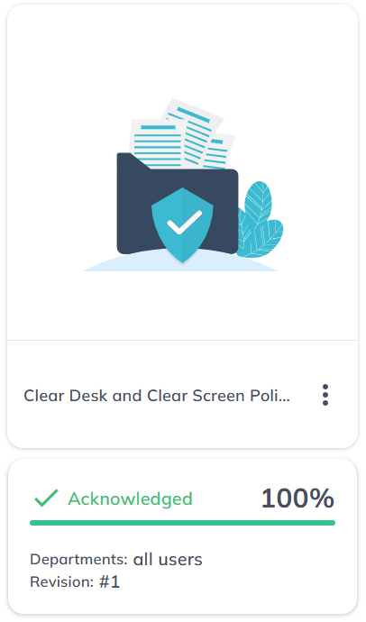

# Recommendation

Following the completed risk assessment and gap analysis, we identified key policies necessary to strengthen the organisation’s security posture in support of its digital transformation objectives. We recommend the immediate implementation of these policies, alongside ongoing staff training conducted at least annually or more frequently in response to regulatory changes or identified incidents to ensure continuous awareness and protection of all information assets.

Additionally, we recommend that Wales Interiors conduct regular internal risk audits and pursue ISO/IEC 27001 certification. This will demonstrate a firm commitment to safeguarding client data, enhancing trust, and achieving a competitive edge in the marketplace.

# Conclusion

By implementing these policies, Wales Interiors strengthens its cybersecurity resilience in alignment with its digital transformation goals and regulatory obligations. The policies have been formally communicated to all relevant teams, and all employees have acknowledged their understanding and compliance. This collective commitment reinforces the organisation’s proactive security posture and positions Wales Interiors competitively in the evolving market landscape.